Software Requirements Specification

For

Technobabel

|  |  |
| --- | --- |
| **Team Members** | Keith Zane, Christopher You, Bryan Robinson, Justin Stryjewski |

# The Revision History

|  |  |  |  |
| --- | --- | --- | --- |
| **Date** | **Description** | **Author** | **Comments** |
| <date> | <Version 1> | <Your Name> | <First Revision> |
|  |  |  |  |
|  |  |  |  |
|  |  |  |  |

# Document Approval

The following Software Requirements Specification has been accepted and approved by the following:

|  |  |  |  |
| --- | --- | --- | --- |
| **Signature** | **Printed Name** | **Title** | **Date** |
|  | <Your Name> | Lead Software Eng. |  |
|  | A. David McKinnon | Instructor, CptS 322 |  |
|  |  |  |  |

**Table of Contents**

Revision History ii

Document Approval ii

1. Introduction 1

1.1 Purpose 1

1.2 Scope 1

1.3 Definitions, Acronyms, and Abbreviations 1

1.4 References 1

1.5 Overview 1

2. General Description 2

2.1 Product Perspective 2

2.2 Product Functions 2

2.3 User Characteristics 2

2.4 General Constraints 2

2.5 Assumptions and Dependencies 2

3. Specific Requirements 2

3.1 External Interface Requirements 3

3.1.1 User Interfaces 3

3.1.2 Hardware Interfaces 3

3.1.3 Software Interfaces 3

3.1.4 Communications Interfaces 3

3.2 Functional Requirements 3

3.2.1 <Functional Requirement or Feature #1> 3

3.2.2 <Functional Requirement or Feature #2> 3

3.3 Non-Functional Requirements 3

3.3.1 Performance 4

3.3.2 Reliability 4

3.3.3 Availability 4

3.3.4 Security 4

3.3.5 Maintainability 4

3.3.6 Portability 4

3.4 Design Constraints 4

3.5 Logical Database Requirements 4

3.6 Other Requirements 4

4. Analysis Models 4

4.1 Data Flow Diagrams (DFD) 4

A. Appendices 4

A.1 Appendix 1 4

A.2 Appendix 2 4

1. **Introduction**

It is is not uncommon to find employees of various corporations to use vocabulary that is native to them. With a company that uses a vast array of unique terminology, employees can find it can be confusing--if not embarrassing--to not know terms they are not familiar with. The purpose of TechnoBabel is to assist employees with learning company vocabulary and term pronunciation.

1.1 PURPOSE

The purpose of this Software Requirements Specification (SRS) is to outline the requirements of the TechnoBabel mobile application to describe the scope of the project. The document will also discuss the details of the software, hardware, and technical dependencies needed for the project. This document is intended to be proposed to the client for approval while also serving as a necessary reference for the development of the TechnoBabel mobile application.

1.2 SCOPE

TechnoBabel is a mobile application that will provide a dictionary of terminology for employees to reference and learn company terminology exclusive to their company.

The mobile application can only be accessed through a username and password. The application will allow employees to search for their company’s terminology through the application’s search functionality or by recording conversations. The app will capture sentences that were stated, and highlight the terms it recognizes based what is listed in the dictionary. When a term is selected, its definition is displayed along with the ability for the application to pronounce it.

Certain employees will be designated administrator privileges, which will allow them to add, edit, and delete vocabulary, as well as grant their company’s employees access to the app.

TechnoBabel will need internet access to allow employees to login to the app, search for terms, edit terms, delete terms, and add new users. All company terminology as well as user credentials will be stored on a database, which is stored on a cloud platform.

1.3 Definitions, Acronyms, and Abbreviations

|  |  |
| --- | --- |
| **Term** | **Description** |
| User | Someone who interacts with the mobile phone application. |
| Admin/Administrator | A user who has been granted specific permission for adding users to the system, adding, editing, and deleting terms in the dictionary. |
| Terminology | The formal statement of the meaning or significance of a word or acronym. |
| Microsoft Azure | A cloud computing service provided by Microsoft. |
| Microsoft SQL Server | A relational database created by Microsoft. |
| Mobile Application/Mobile App | A computer program designed to run on a mobile device such as a phone/tablet or watch. |

1.4 REFERENCES

PLACEHOLDER TEXT

1.5 OVERVIEW

The rest of this document will give a detailed breakdown of the components that will make up this project. The first component will provide an overview of the system functionality. The second will provide a list of the detailed specific system requirements. The third will provide analysis models including a data flow diagram.

1. **GENERAL DESCRIPTION**

2.1 PRODUCT PERSPECTIVE

TechnoBabel is a cross-platform mobile application intended for use on both Android and iOS devices. While the TechnoBabel mobile application is the main focus of the project, there is also a server-side/cloud-based component which will be responsible for database and synchronization services. The scope of the project encompasses both server and client-side functionalities, so both aspects are covered in detail within this document. Below is a diagram of the TechnoBabel system which illustrates the interactions between the server and client application.

PLACEHOLDER DIAGRAM

2.2 PRODUCT FEATURES

1. User Login
   1. The first screen the user sees when using the application for the first time.
   2. The user authenticates with a username and password recognized on the database
2. Main Screen
   1. After logging in, the user will see a screen with 2 options available to them (4 if they are an admin user).
   2. The user will be able to search for terms by pressing the Search button, or search for terms by using the speech to text function.
   3. If the the user is an admin, they will see two more options. The first being a button which allows the admin to grant more users access to the dictionary. The second button enabling them to add, edit, and delete terminology.
3. Listen For Terminology
   1. When the Listen button is selected, the app activates the phone’s microphone, waiting to hear someone speak. When someone speaks, it takes what they said and searches for terms found in the dictionary. If found, it will list those terms which the user can select to read the definition.
   2. When a term is selected, its definition is displayed along with a button for the app to pronounce the term.
4. Search for Terminology
   1. When the user clicks the Search button, they will see a search field which they can enter a term to find terms. The application will go out to find terms based on what the user entered.

2.3 USER CHARACTERISTICS

The mobile application will be accessed by users that have general knowledge of how to use an app on an Android or iOS device. Assumed mobile device knowledge includes a prior understanding of general mobile device use and app navigation skills. In order to understand and apply the full functionality of the application, it is assumed that the user knows what a dictionary is and how to use one.

## 2.4 GENERAL CONSTRAINTS

This section will list and describe all constraints. Both business and technical constraints for TechnoBabel will also be included.

## 2.4.1 BUSINESS CONSTRAINTS

Users will not have access to the application until user account information is added to the database.

The Project must be completed by December 7th. In order to be successful, all group members must spend enough time to ensure that all personal and team goals are met throughout the life of the project.

## 2.4.2 Technical Constraints

An internet connection is a constraint for the application. The user must be connected to the internet in order to access the mobile application.

3. **Specific Requirements**

This section will describe all specific requirements including: External Interface Requirements, Functional Requirements, Non-Functional Requirements, Design Constraints, Logical Database Requirements, and Other Requirements.

3.1 EXTERNAL INTERFACE REQUIREMENTS

This section provides visual and detailed descriptions of all user interfaces from the system.

3.11 *User Interfaces*

* The back button shall allow users to back track activities. The order of activities is as follows:

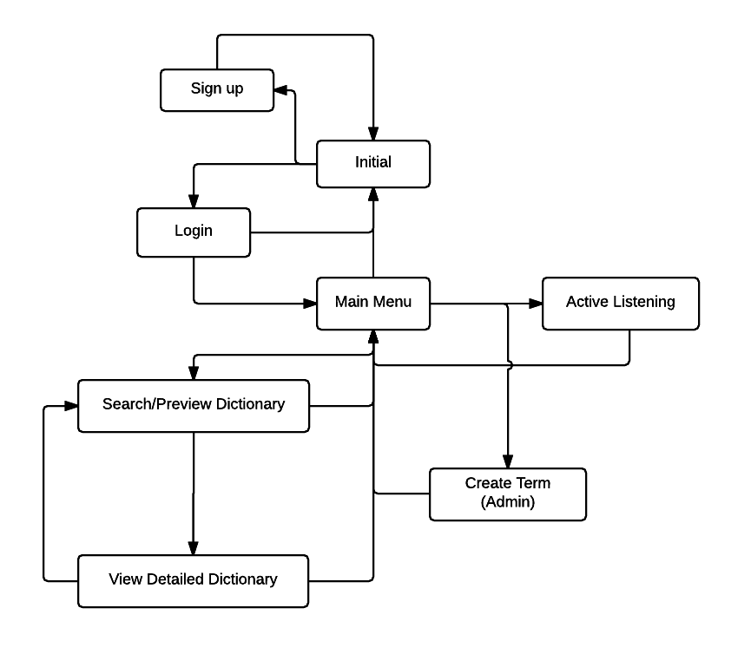

3.111 Initial Activity

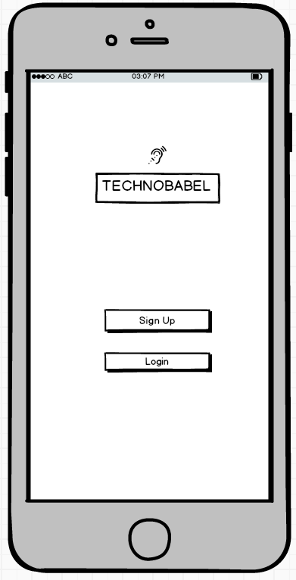

* Allows users or administrators to sign up for a new account or login to a preexisting account

3.112 Sign Up Activity

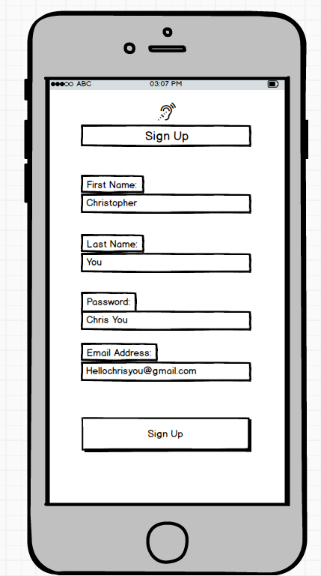

* Sign up activity for first-time users
* Prompts user to enter profile information to be stored on the server
* System shall notify user if information is invalid

3.113 Login Activity

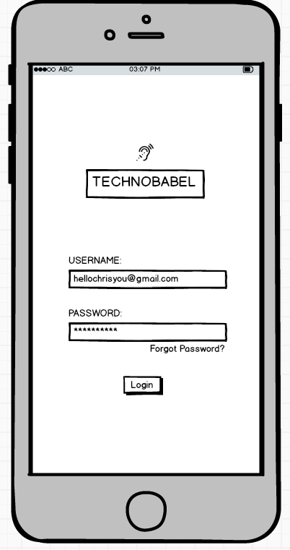

* User will be prompted to put in login information
* Notifies if log information is valid
* User will have an option to retrieve password via email

3.114 Main Menu Activity

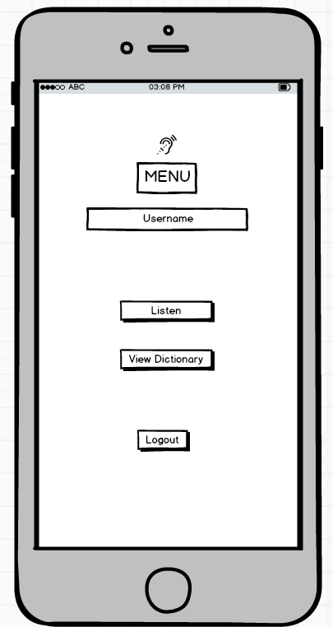 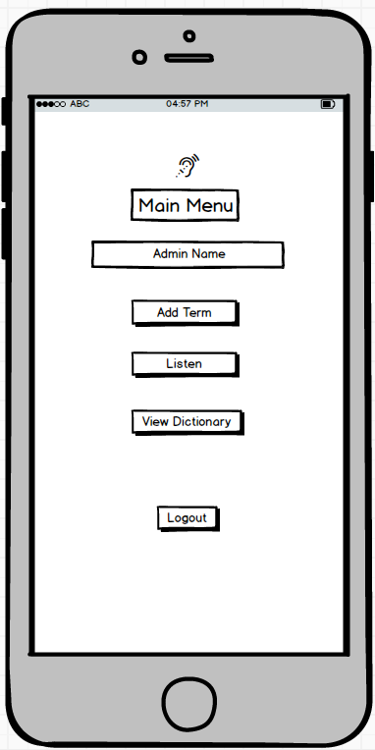

* Display options to visit Listen Activity, Search/Preview Dictionary Activity, Active Listening Activity
* Offer administrators an option to add terminology
* Users will have option to logout and returned to the Initial Activity

3.115 Search/Preview Dictionary Activity

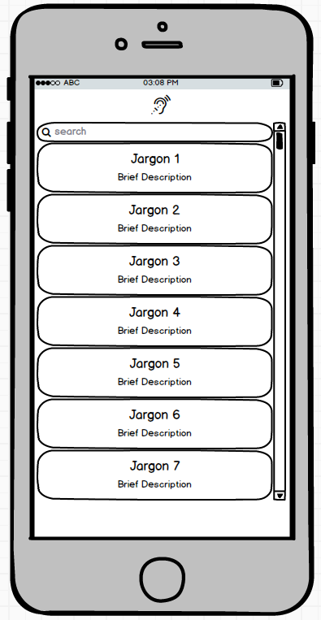

* Offer users a search bar to find and view terminology in database
* Shows a scrollable list that displays available terms and preview of the definition
* Selecting a term will direct user to View Detailed Dictionary Activity

3.116 View Detailed Dictionary Activity

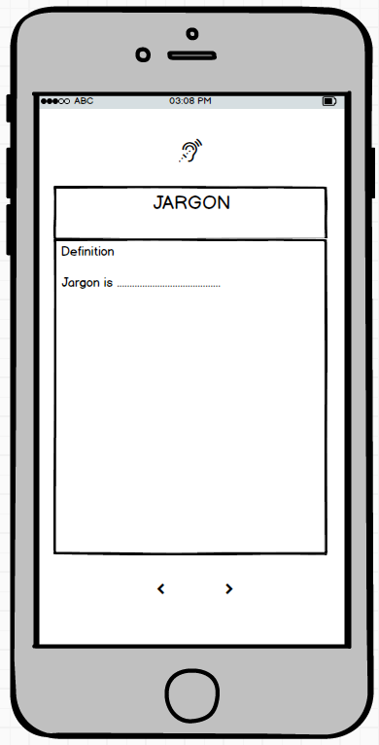 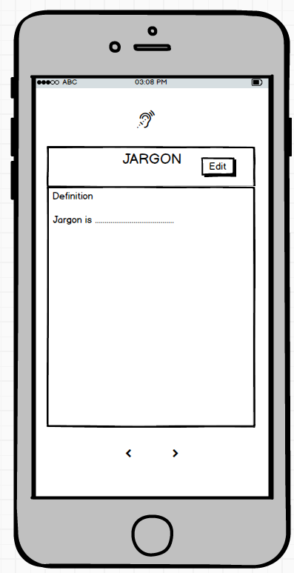

* Shows detailed information about selected term.
* Administrators will have the option to edit definitions
* Users can cycle terms forward and backwards alphabetically

3.118 Create Terminology Activity

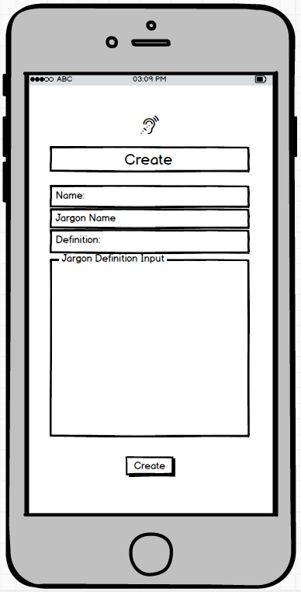

* Only administrators will have the option to create terminology
* Administrator is prompted to enter terminology name and definition

3.117 Active Listening Activity

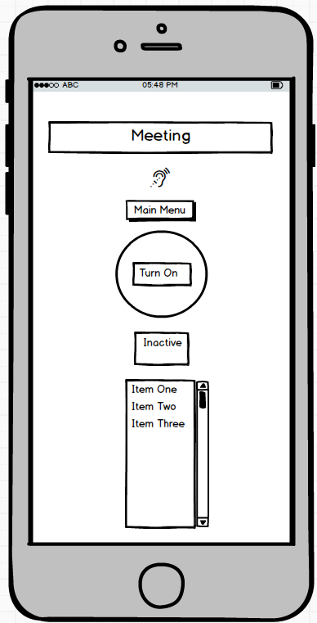

* Allows users toggle voice recorder on/off to actively listen and identify terminology in database
* Shows users status of voice recorder
* Recognizes and displays terms in a scrollable list
* Offers users to option to visit main menu

3.12 *Hardware Interfaces*

Technobabel is intended as a mobile application for Android and IOS. The hardware connection to the database is managed by the underlying operating systems on the mobile phone.

Technobabel is being developed for a maximum API version of 19 and supports voice recognition.

3.13 *Software Interfaces*

The application is to be developed under the Xamarin platform using BLANK DEVELOPMENT KIT for IOS and the Android SDK (software development kit) tools for Android.

Incoming and outgoing data consists of account information, terminology data, and audio data. The Xamarin platform handles recording audio information and then transfers that information to the Microsoft Bot framework which then analyzes and hosts the database.

3.14 *Communications Interfaces*

Technobabel application will interact between the front-end framework(Xamarin) and the back-end server (asp.net) by connecting and querying the database on Microsoft Azure (cloud-based platform).

3.2 FUNCTIONAL REQUIREMENTS

1. The Technobabel application shall allow users to create an account

*Description:* Users create their user account and provide their required information. The application saves the data into the system database.

1. The Technobabel application shall allow users to sign in with an existing account

*Description:* Users log into system with existing accounts with approved credentials

1. The Technobabel application shall allow users to retrieve forgotten passwords

*Description:* Users receive email notification of account password once system is prompted

1. The Technobabel application shall approve log-in information and grant access to user

*Description: A*pplication verifies credential information from the database and grant approval

1. The Technobabel application shall only allow administrators to create/edit terminology

*Description:* Administrators utilize application to create/edit terminology from/to the database

1. The Technobabel application shall allow users to view terminology

*Description:* Users may view available terminology from the database

1. The Technobabel application shall allow users to logout of their accounts

*Description:* Users may log out of their accounts at the main menu

1. The Technobabel application shall allow users to search and preview terminology from the database

*Description:* Users can search for available terminology from the database and system displays results with a preview description

1. The Technobabel application shall allow users to toggle voice recorder on/off

*Description:* Users have the option to turn voice recorder on or off when desired

1. The Technobabel application shall recognize terminology via voice recorder

*Description:* Voice recorder will recognize existing terminology from database when activated

1. The Technobabel application shall populate definitions from recognized terminology

*Description:* Application displays to the user the selected terminology definition from the database

1. The Technobabel application shall generate notifications for invalid login or sign up information

*Description:* Application will recognize invalid login or sign up information and prompt user to enter valid information

1. The Technobabel application shall display status of voice recorder

*Description:* Application will recognize and display the status of the voice recorder

3.3 NON-FUNCTIONAL REQUIREMENTS

3.4 DESIGN CONSTRAINTS

In this section is the design constraints that are put on the application:

3.4.1 Screen Size

Due to being a mobile application the screen size will be limited to no bigger than 12.9 inches but also no less than 4.7 inches. This is in order to accommodate both phone mobile devices as well as tablets.

3.4.2 Software Language

This application will be built using the Xamarin Framework, therefore all code must be done in the form of C# and XAML.

3.4.3 Application Size and Memory Usage

The application will be development for a mobile environment which means that there will not be a lot of extra memory space for the application to use. Therefore, the application should be running efficiently and be aware of the amount of data is loaded at a time.

3.5 LOGICAL DATABASE REQUIREMENTS

There are three major entities that the database will have to account for. The following table shows those entities as well as the attributes that they have. This also has a logical relationship between entities:

|  |  |  |  |
| --- | --- | --- | --- |
| Data Entity | Attributes | Usage | Relationship |
| User | * UserID * First Name * Last Name * Username * Email * Password * PasswordSalt * AdminStatus * CompanyID | The User entity serves as a logon for the company employee. The password will be stored as an encrypted string which is found by the password combined with its salt encrypted. | The user can only have one company attached to it, but must have a company attached to it. |
| Company | * CompanyID * CompanyName | The company entity serves as a relationship bridge between the terms and the user. | There are no specific requirements for a Company. |
| Term | * TermID * Term * Definition * CompanyID | The Term entity serves as a definition of the named term. | The term can only have one company attached to it, but must have a company attached to it. |

3.6 OTHER REQUIREMENTS

3.6.1 Secure

The application uses data that is very sensitive to the companies that are using this application. The data must be treated with care. There are many pieces of information that need to be handled so that the user can effectively use the application. This includes security in these major parts:

* Company Dictionary Security
* Company Login Security
* Account Creation Security

3.6.2 Available

The application must be able to connect to the database during online usage. Thus, the database must be available with a 99% uptime. The device must also have access to the phone’s microphone in order to record audio that can be used by the application to show key phrases that the company introduces.

3.6.3 Reliable

The application must be able to ensure that the information the user asks for is accurate. When the user queries the database for information, only information for the company that they work for should be shown.

3.6.4 Testable

The application must have functionalities that are able to be tested by the developers. This means that the functionalities should have repeatable scenarios with a clear idea of what the result should be.

3.6.5 Adaptable

The application will be designed for both the android and iOS environments. Thus, the application must be able to be adapted to both of these different types of phones. However, the application must give the same feel when being used on either an android phone or an iOS phone.

3.6.6 Responsive

The application will be designed with the user experience in mind. Therefore, the application must be able to respond to any stimuli within 2 minutes of the user interacting with the application. This should also be done in a way that shows visual confirmation of requests and commands.

**4. Analysis Models**

4.1 Data Flow Diagram

